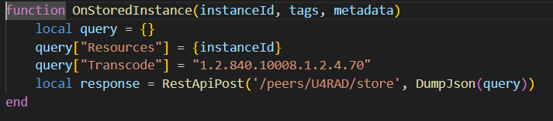

**OnStoredInstance() –** This function is run whenever the local orthanc server will receive an instance from the DR/CR/etc.

**query[“Resources”] = {instanceId} –** Sets the current resource to the instance that is currently stored

**query[“Transcode”] = “1.2.840.10008.1.2.4.70” –** Sets the resource’s transfer syntax to JPEG-Lossless

**local response = RestApiPost… -** This line uses the orthanc server’s REST API to send the transcoded instance to the cloud server (it is set as a peer called U4RAD)

**TO DO**

* Add a function that deletes the study once it has become ‘stable’ so that any study is not stored in the local orthanc for too long (decide how long the study should be stored in the local orthanc and set the StableAge parameter in u4rad.ps1 accordingly)
* Code will look something like this: 